姓名 | 董瑞麟
教育经历 | 2022-2026, Southern University of Science and Technology, Dept. of Mechanical and Energy Engineering, B.Eng. in Mechanical Engineering. (Expected)
电子邮箱 | 794876983@qq.com
个人照片 | 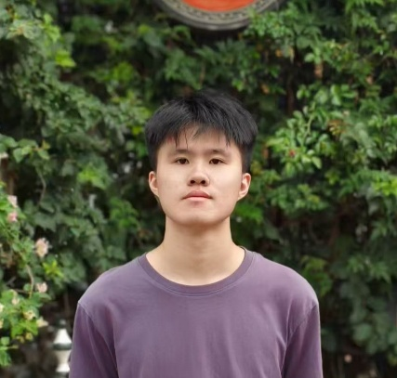
研究领域 | 我是bachelor
自我介绍 | Hi! I’m Ruilin, a mechanical engineering major working toward my bachelor’s degree. If everything goes well, I’ll continue here to pursue my master’s degree. Anyway, it’s a really nice place for academic collaboration and teamwork.
论文发表情况 | IEEE Transactions on Medical Robotics and Bionics,  "Natural Movement-Based Pose Optimization for  Robot-Guided Upper-Limb Rehabilitation System" (Early Access)

